This document shows typical performance and timings of the USB VNA interface. Note that these traces were obtained from an earlier version of the firmware.

First, a sequence of 3 ADC conversions in succession (USB interface asked to make 3 ADC readings in one operation)

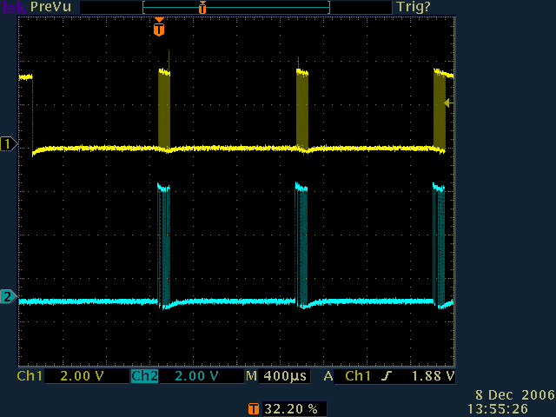

Top trace is clock (ADC SCLK), lower is serial data out from ADC (SDO)

Note the clock is left high at end keeping ADC in sleep mode, ready for another conversion. Clock was also high at the start – the ADC was being held from a previous conversion but the CS reset process shown in a couple of pages will still have been used at the start of the first conversion.

CS is not affected between readings as the ADC count was set to 3, so ADC is restarted just by dropping clock low.

Zooming in on the reading of the first ADC result from the previous trace (the trigger point shown by the red ‘T’ in the previous and this display.

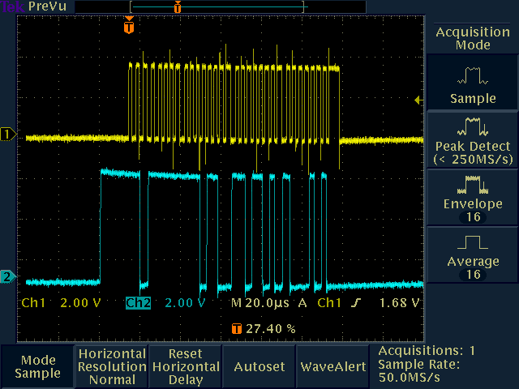

It can be seen that there is slightly slower timing until bit 5. This is caused by the setting of SDI for speed of the next conversion.

There is a pause at end which is the minimum delay until next conversion (5.1 usec ). Also note that at the start of the reading of the ADC result it took about 14 usec to realise that SDO had gone low (high in this case due to transistor inverter in VNA) before we started clocking out data. This time varies asynchronously.

It took 98.6 usec to clock the result out of the chip. The per bit time is about 3.6 usec for the first 5 bits and 2.8 usec for the rest with an extra 2.4 usec between bytes

As the above trace shows an intermediate result in a sequence of conversions, the next conversion is triggered just by clock going low.
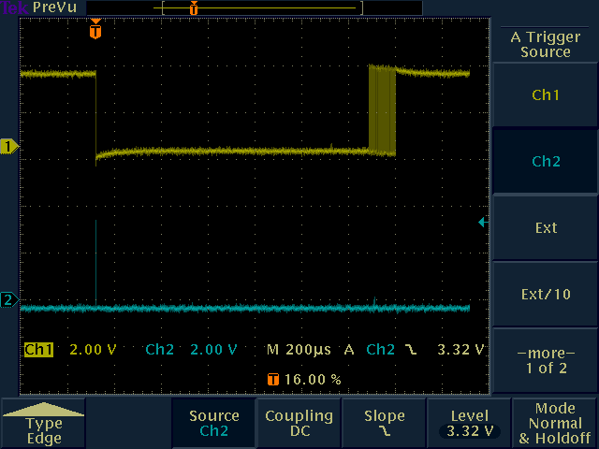

Above is a single conversion. Lower trace is CS line, upper is SCLK. Note single pulse of CS at start. This is always done at the start of a sequence of AD conversions.

Zooming in on ADC sequence. CS goes high (starting conv) clock low then CS low to ensure external clock mode of ADC.

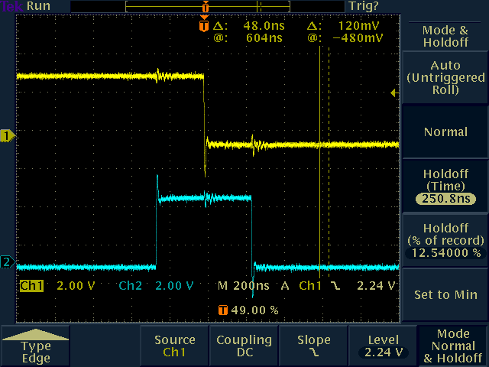

Now select ADC2 and do a convert (ADC2 missing in this setup, SDO is tied low), Note ADC1 CS goes high. ADC2 conversion completes immediately (as SDO is forced low for testing) and ADC1 CS remains high at the end (as does ADC2 CS in case another conversion on ADC2 is requested). At this point the code knows that ADC2 is ready for another conversion but ADC1 will need to be cleared of a conversion.

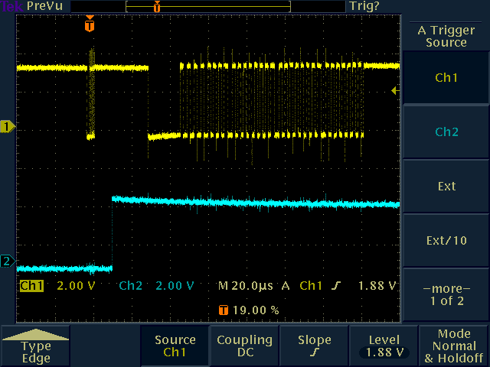

Looking in detail at the clock sequence, the first set of transitions is the resync of ADC2 from its previous state – 5 falling clock edges then CS high, clock low, CS low. An example of this is shown overleaf. The first falling edge of this clock will actually trigger ADC1 conversion as it was being held with clock high after the 32nd bit, so the extra clocks and raising of CS are in fact ignored.
Now switch back to ADC1. ADC1 CS was high during the previous ADC2 conversion, so previous conversion needs clearing. Clock is taken low (this will start ADC2), then CS goes low. Code checks that SDO is low (will wait if not) then clocks 5 times (5 falling edges). After 17 usec delay for code machinations, we get normal startup sequence ( CS high to start, clock low, CS low). There is an inherent delay of 12 usec before the series of clock cycles. This is for code convenience only. It has no practical impact as switching ADCs like this is not normal.

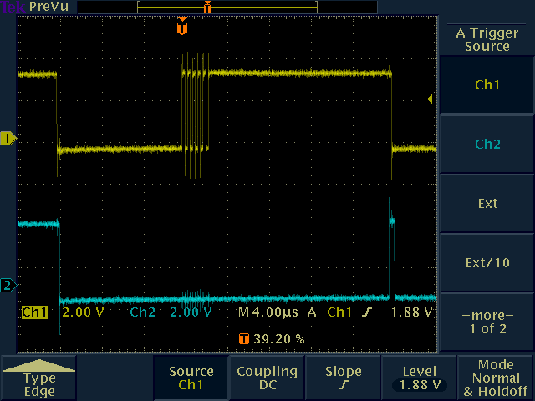

The next conversion on ADC1 carries just the startup sequence

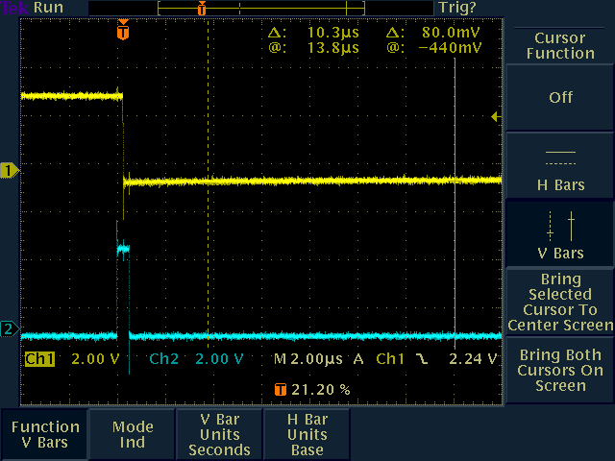
DDS FQ_UD to ADC start delay

With zero delay selected, it now takes 54 usec from FQUD signal to start of ADC conversion (first trace). This is controlled by an internal delay setting (default =4) that enforces a minimum time for the ADCs to settle of 50 usec. This can be changed by setting the delay parameter with the Configure command. Setting it to zero gives the minimum possible delay of 26 usec (second trace).

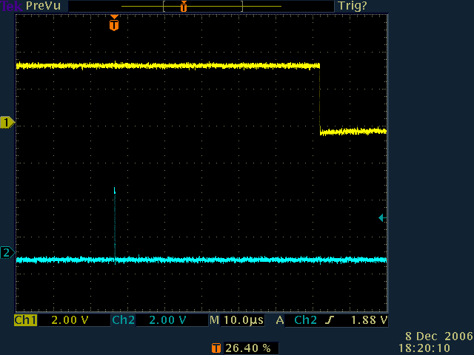
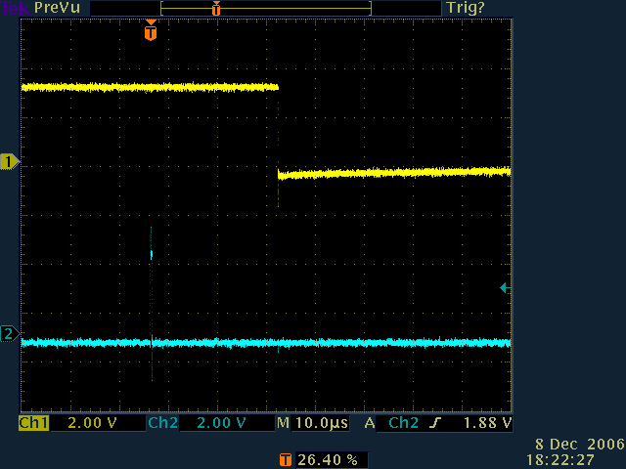

DDS writing time. To write 40 bits of DDS data to both DDS chips takes 79 usec (1.34 usec per bit, 9.64 usec per byte, 7.8usec delay between bytes. The delay from end of DDS update to FQUD if done at same time is 2.58 usec.
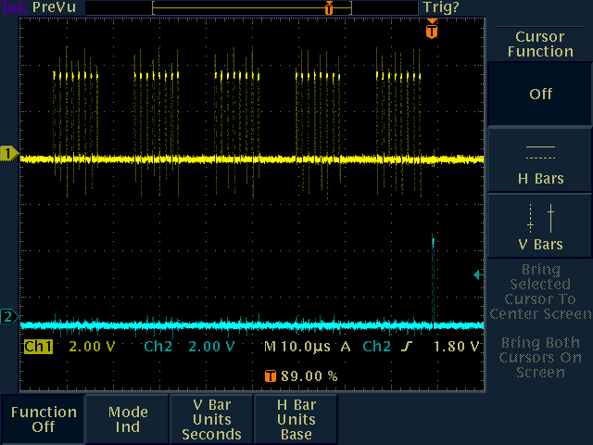
This is the end of the operation (last bit to FQ_UD)

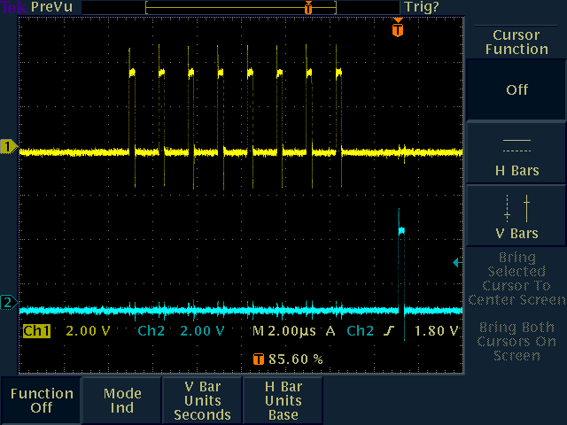
Power on sequence. Here is first ADC conversion (CS and clock were both low). Top trace is clock, bottom is SDO. In second trace, top is clock, bottom is CS

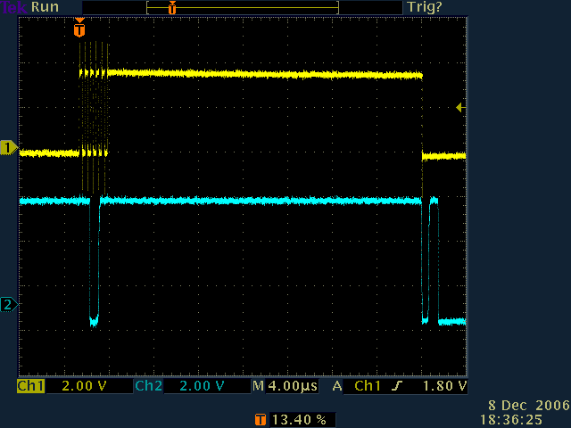
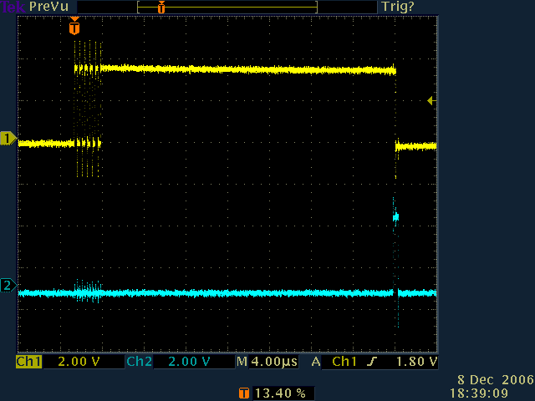
There is a delay of about 1.5usec before SDO is correct. I read the SDO line just after starting a conversion, and read it too soon. I have introduced a small delay. This I do not like! It is weird.
Quadrature conversion.

With the extended set command, can now give it two sets of DDS data. It will perform the requested ADC operations with first set then change DDS data and do the second set. Also it updates the DDS immediately after the first conversion starts and pulses FQUD at the end of the first.

Exact sequence is as follows

- Set DDS to first frequency
- Pulse FQ_UD
- Wait for the requested delay (or minimum delay otherwise)
- Start ADC conversion(s) for given number of reads
- Set DDS to second frequency
- Wait for ADC read sequence to complete
- Pulse FQ_UD
- Start ADC conversion(s) for given number of reads
- Retuen full set of data

Note that ADC conversions may be on ADC1, ADC2 or concurrent. The DDS update and FQUD must happen in the same command – do not set CmdVnaSetDdsFlagsDdsSetSingleFunction flag.

Traces on following pages….
Here is such a reading. First trace shows ADC clock at top and FQ_UD underneath

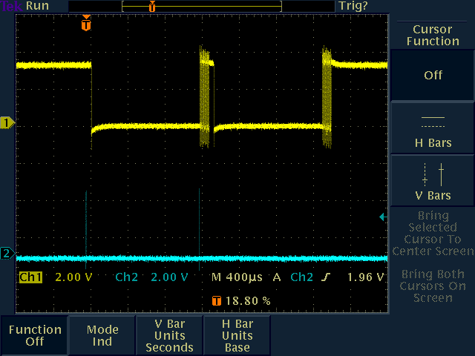

Second trace is ADC clock and DDS clock.

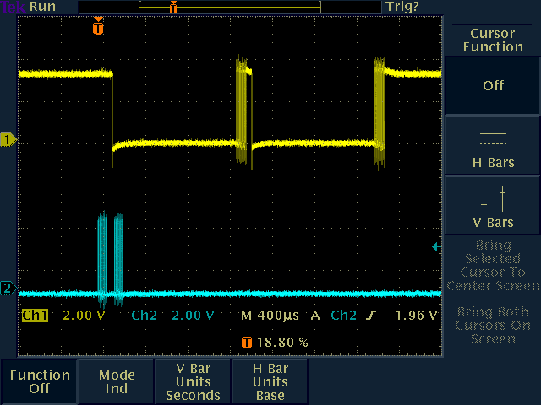
Zooming in on the startup (DDS setting), the DDS updates take 80usec each now. There is a 26.4usec delay from the end of the DDS update until the ADC conversion starts. The FQUD actually happened just 1usec after the end of the DDS update. The second DDS setting starts 14usec after ADC conversion starts and is finished well before the conversion ends.

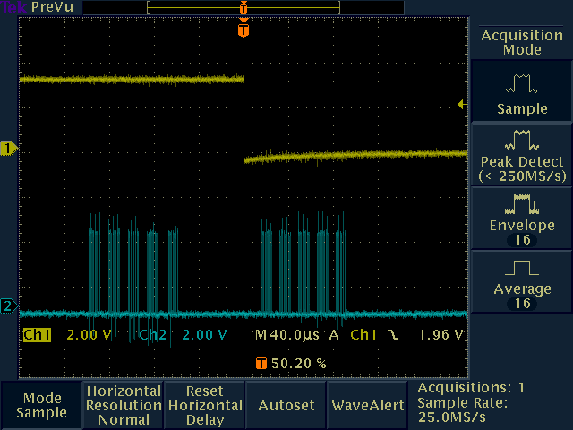
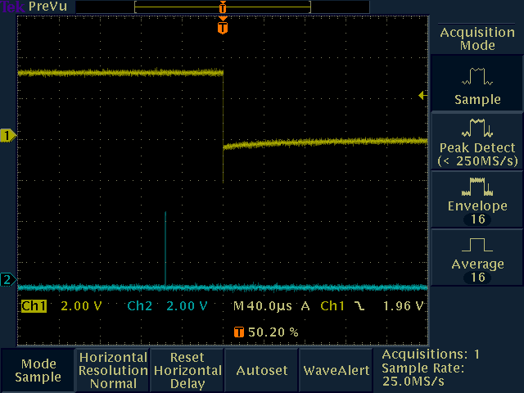
Here is the intermediate conversion (or last of a sequence if the ADC count was > 1)

Upper trace is ADC clock, lower trace is DDS FQUD

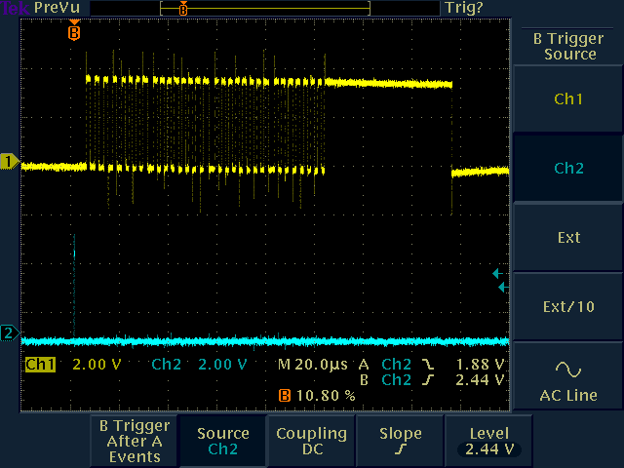

The reading of the ADC result took 98 usec. FQUD was pulsed 5.2 usec before the ADC result was read. The next AD conversion started on the falling edge of the clock 52.4 usec after the end of reading the ADC conversion. This is the minimum ADC conversion startup time – it could be shortened as the timer could be started from the FQUD signal and not from the end of the previous ADC conversion.
In practice – VNA4win

Here is a trace from VNA4win. IN this case the sweep is set to 0 delay, average 1, 3.52KHz rate. VNA4win (a test version from Ian & Roger) makes use of the parallelism offered by queueing up the second measurement in a pair of measurements at each frequency. It does not overlap the setting of the next frequency step as can be seen by the alternating pairs of delays (short / long / short etc).

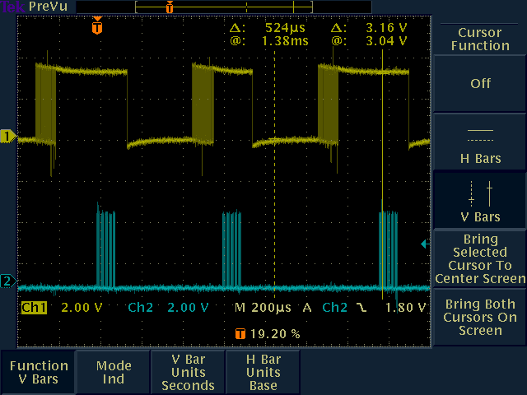

The trace shows DDS clock at the bottom and ADC clock at the top.

The time from start of ADC conversion (clock low) until the USB chip has recognised that the ADC has finished is 313 usec (datasheet conversion time is 284 usec but I do not know the actual clock speed of my ADC). The delay from the end of DDS setup to ADC start was 57 usec. DDS setting time was 88 usec. Reading the ADC result was 100 usec. The delays from end of ADC conversion to start of DDS loading were 200 usec and 44 usec. The additional 160 usec is because the optimisation here is only of pairs of readings at one frequency and does not extend to queueing up the next frequency point. The overall rate of conversion (taking these as pairs) would be 1.37 msec per frequency point (2 ADC cycles and 2 DDS settings) or 730 points per second. This is also the observed behaviour on the screen with 5.6 seconds per 10 sweeps of 400 points reflection mode as timed on a stopwatch ( 714 conversions per second). Paralleling up the next data point would save 200 usec per pair of readings increasing the speed to 855 points per second.

Exeter

The integration of the USB interface into Exeter is at a lower level, so overlapping requests, queuing them up in the chip, is not possible. The delays between reads are therefore much more even.

There are also more calls made to the VNAccess.dll as a result, but the replacement VNAccess.dll tries to minimise the USB calls, fooling Exeter a bit.

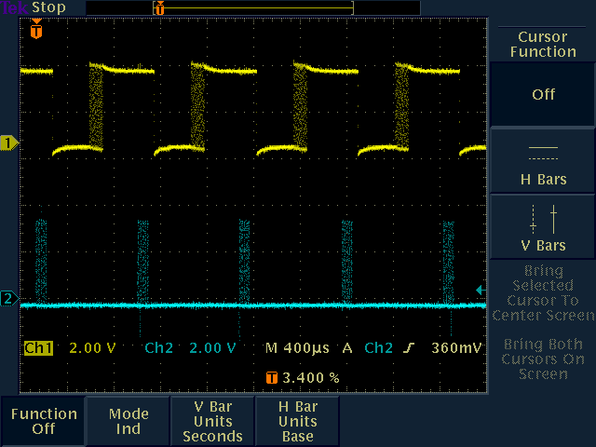

Zooming in on one cycle…

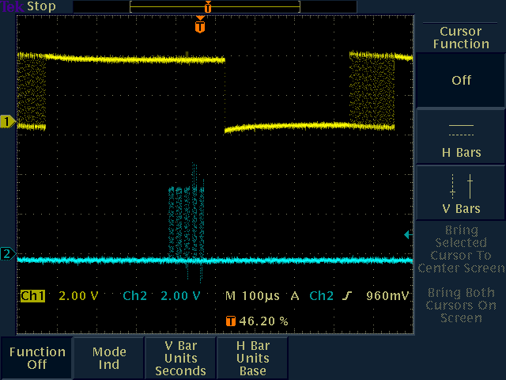

The delay from the end of a data conversion to the next DDS load is 312 usec. If requests were queued up this would take 44 usec, and in the case of VNA4win the corresponding delay was 243 usec.

DDS loading takes 88 usec. The delay to the ADC start is 53.2 usec. ADC conversion again takes 314 usec until the USB chip recognises it has completed and ADC data output takes 112 usec.

The overall sampling rate for DDS load and ADC convert is 878 usec per pair, and for a pair of two conversions at one frequency this takes 1.756msec, or a scan rate of 570 points per second.

Exeter has a “minimise setup time” function. Selecting this speeds things up slightly saving 12 usec per point, making the overall rate 577 points per second.

Sweep Mode

With this (sweep of 3 points, step delay 1msec, initial delay 2msec, switch output off between sweeps, pulse SW1 output during sweep)

Command = AA 90 01 02 00 00 00 03 04 00 00 00 00 00 01 B9 CB AA 04 00 00 00 00 00 00 DC E5 D5

This is the result. 2msec between sweeps and 1 msec per step

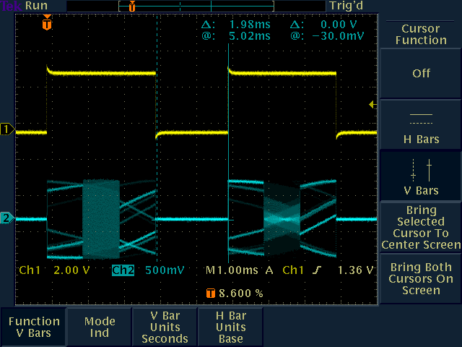

With this
AA D0 17 02 00 00 00 03 04 00 00 00 00 00 01 B9 CB AA 04 00 00 00 00 00 00 DC E5 D5

The result is this which is a 2 msec delay and roughly 192 usec per step
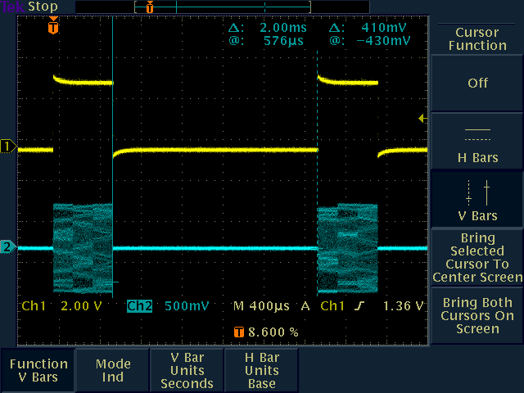

Changing msec delay between sweeps to 1 get this:
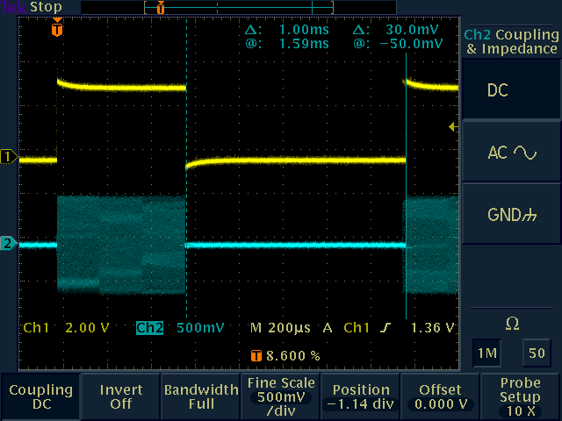

Finally changing to
AA B0 01 17 00 00 00 03 04 00 00 00 00 00 01 B9 CB AA 04 00 00 00 00 00 00 DC E5 D5

Gives 194 usec between sweeps and 1 msec per step
